**TRIBHUVAN UNIVERSITY**

**INSTITUTE OF ENGINEERING**

**Lab Sheet #10**

**PURWANCHAL CAMPUS**

DHARAN-8

**Submitted by:** **Submitted to:**

Name: **Arbind Kumar Mehta** Department of

Roll No: **PUR075BCT017** Electronics & Computer

Faculty: BCT Engineering

Group: I/I ‘A’

Date: ….......................... Checked by: ……………………….

**Title:**

Write characters into a file “filec.txt”. The set of characters are read form the keyboard until an enterkey is pressed (use putc() and getc() function).

**Code:**

#include <stdio.h>

#include <stdlib.h>

int main()

{

char ch[50];

int i=0;

FILE *file;

file=fopen("D:\\file.txt","w");

if(file==NULL)

{

printf("File cannot be opened!!!\n");

exit(1);

}

printf("Enter character to be written in file:\n");

gets(ch);

while(ch[i]!='\0')

{

fputc(ch[i],file);

i++;

}

fclose(file);

getch();

return 0;

}

**Output (Compilation, Debugging and Testing):**

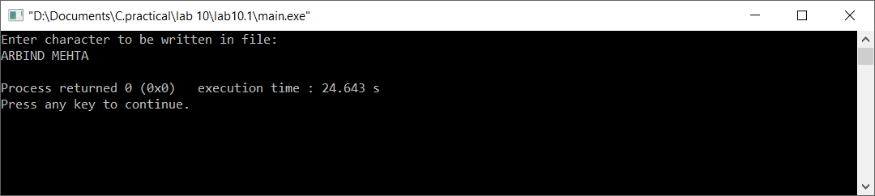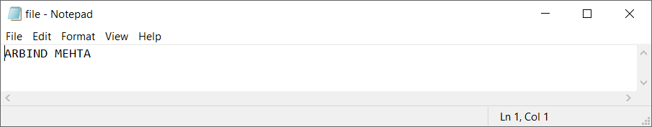

**Title:**

Read characters form file “filec.txt” created in question 1. Also count the number of characters in the file (use fputs() and fgets() function).

**Code:**

#include <stdio.h>

#include <stdlib.h>

int main()

{

char ch[50];

int i=0;

FILE *file;

file=fopen("D:\\file.txt","r");

if(file==NULL)

{

printf("File cannot be opened!!!\n");

exit(1);

}

printf("The character stored in file are:\n");

while((ch[i]=fgetc(file))!=EOF)

{

printf("%c",ch[i]);

i++;

}

printf("\nThe number character in file is: %d",i);

fclose(file);

getch();

return 0;

}

**Output (Compilation, Debugging and Testing):** 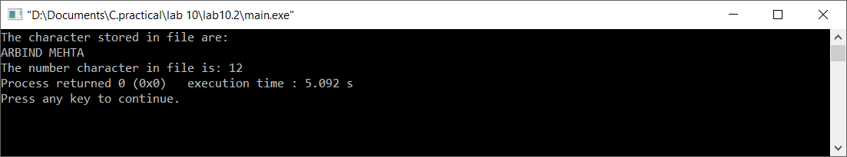

**Title:**

Write set of strings each of length 40 into a file “stringc.txt” and display it (use fputs() and fgets() function).

**Code:**

#include <stdio.h>

#include <stdlib.h>

int main()

{

char ch[50],s[50];

FILE *file;

file=fopen("D:\\file.2.txt","w");

if(file==NULL)

{

printf("Cannot open file!!!");

exit(1);

}

printf("Enter a string:\n");

gets(ch);

fputs(ch,file);

fclose(file);

printf("Press any key to view string.\n");

getch();

file=fopen("D:\\file.2.txt","r");

fgets(s,sizeof(s),file);

printf("You have entered: %s",s);

fclose(file);

getch();

return 0;

}

**Output (Compilation, Debugging and Testing):**

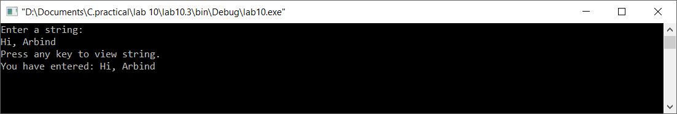

**Title:**

Write name, age and height of a person into a data file “person.txt” and read it (use fprintf() and fscanf() function)

**Code:**

#include <stdio.h>

#include <stdlib.h>

struct per

{

char nam[30];

float ag,ht;

}p1;

int main()

{

FILE *fptr;

int n,i;

fptr=fopen("D:\\person.txt","w");

printf("Enter number of person:");

scanf("%d",&n);

for(i=0;i<n;i++)

{

printf("Enter name age and height of person:\n");

scanf("%s%f%f",p1.nam,&p1.ag,&p1.ht);

fflush(stdin);

fprintf(fptr,"%s\t\t%.2f\t%.2f\n ",p1.nam,p1.ag,p1.ht);

}

fclose(fptr);

printf("Enter any key to view record.\n");

getch();

printf("Name\t\tAge\tHeight\n*******************************************************************\n");

fptr=fopen("D:\\person.txt","r");

while(!feof(fptr))

{

fscanf(fptr,"%s%f%f",p1.nam,&p1.ag,&p1.ht);

printf("%s\t\t%.2f\t%.2f\n",p1.nam,p1.ag,p1.ht);

}

fclose(fptr);

return 0;

}

**Output (Compilation, Debugging and Testing):**



